Test Case: tc005_SPX_Dev5_Crear_Requisicion_Spot_Con_FAD_Tipo_Cobro_Project
Step 1 - Enter username and password and click to button Enter: Credentials Entered
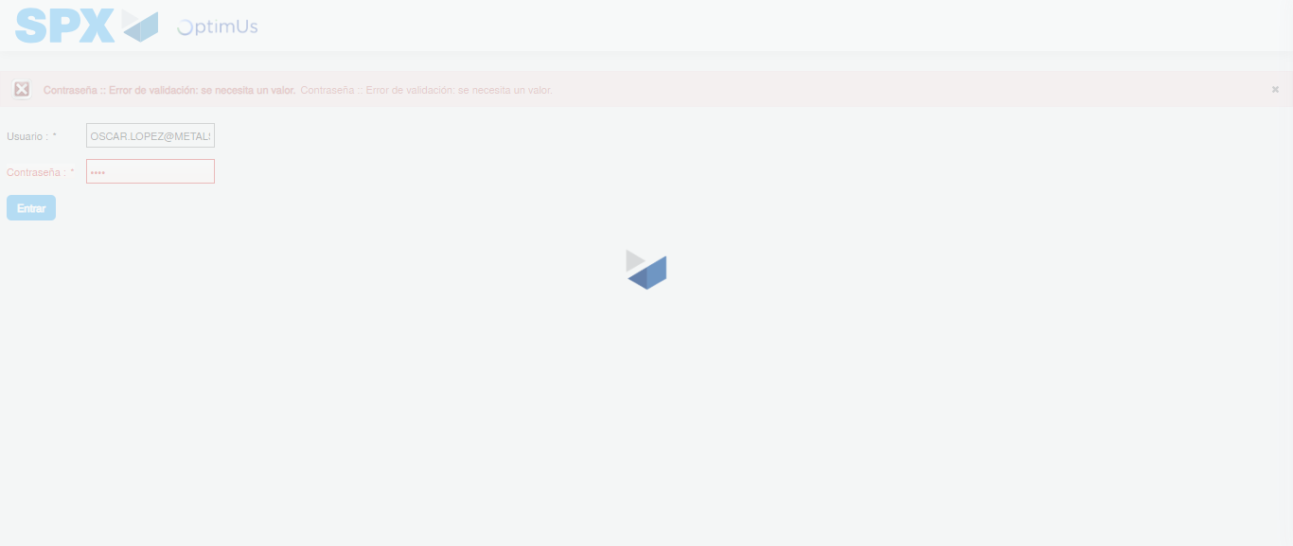Image file-name: QC_Testing-tc005_SPX_Dev5_Crear_Requisicion_Spot_Con_FAD_Tipo_Cobro_Project-1784571397853

Step 2 - Select to UEN and Access to Spot Buy Requisitions : UEN Correctly selected and Correct access
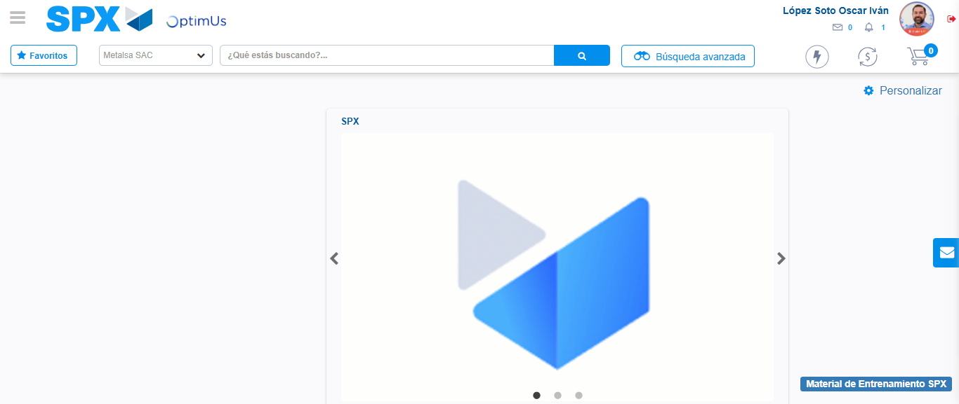Image file-name: QC_Testing-tc005_SPX_Dev5_Crear_Requisicion_Spot_Con_FAD_Tipo_Cobro_Project-1784571471045

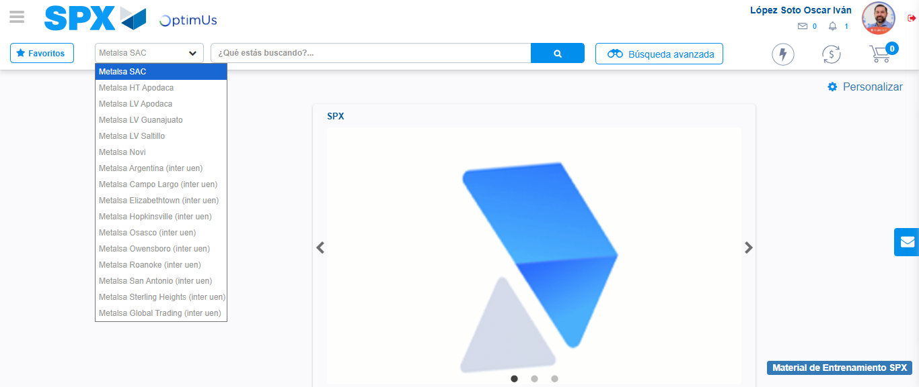Image file-name: QC_Testing-tc005_SPX_Dev5_Crear_Requisicion_Spot_Con_FAD_Tipo_Cobro_Project-1784571473558

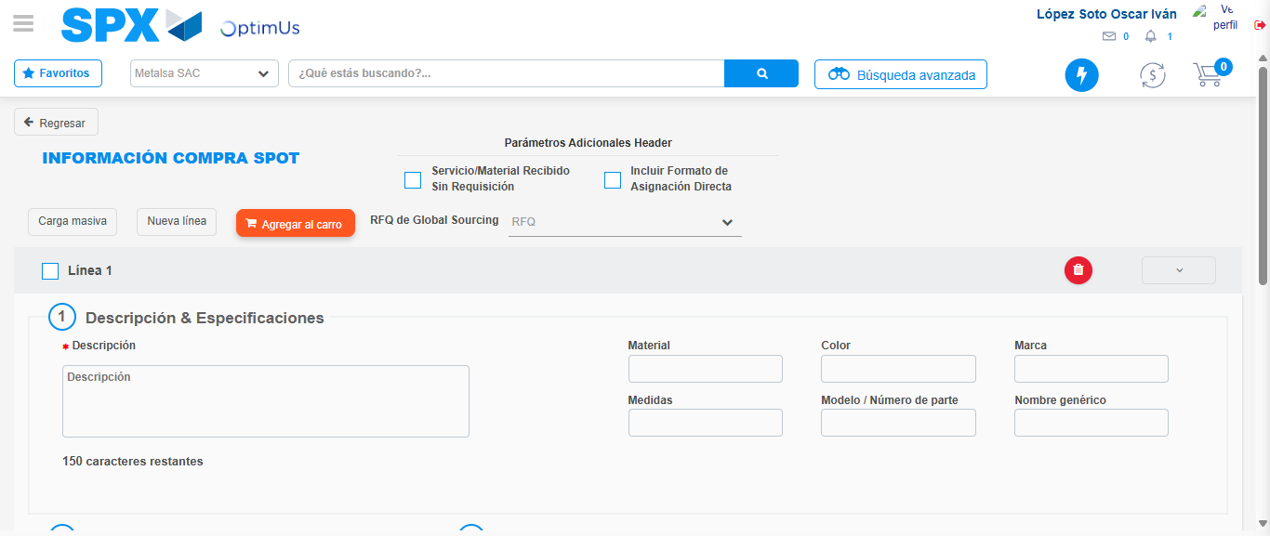Image file-name: QC_Testing-tc005_SPX_Dev5_Crear_Requisicion_Spot_Con_FAD_Tipo_Cobro_Project-1784571491773

Step 3 - Add FAD to Requisition: FAD Successfully Added
Image file-name: QC_Testing-tc005_SPX_Dev5_Crear_Requisicion_Spot_Con_FAD_Tipo_Cobro_Project-1784571491998

Image file-name: QC_Testing-tc005_SPX_Dev5_Crear_Requisicion_Spot_Con_FAD_Tipo_Cobro_Project-1784571492177

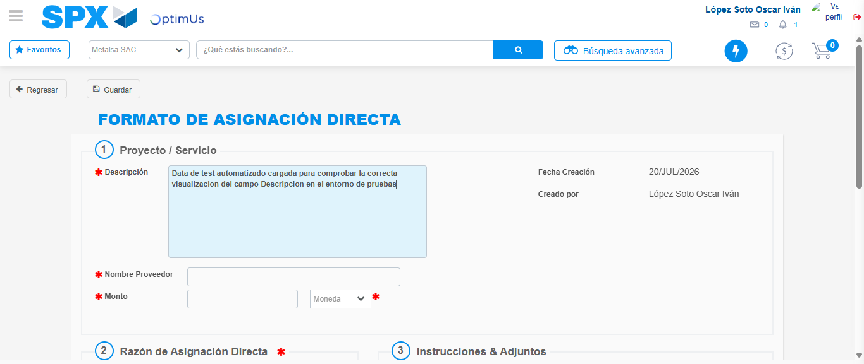Image file-name: QC_Testing-tc005_SPX_Dev5_Crear_Requisicion_Spot_Con_FAD_Tipo_Cobro_Project-1784571495017

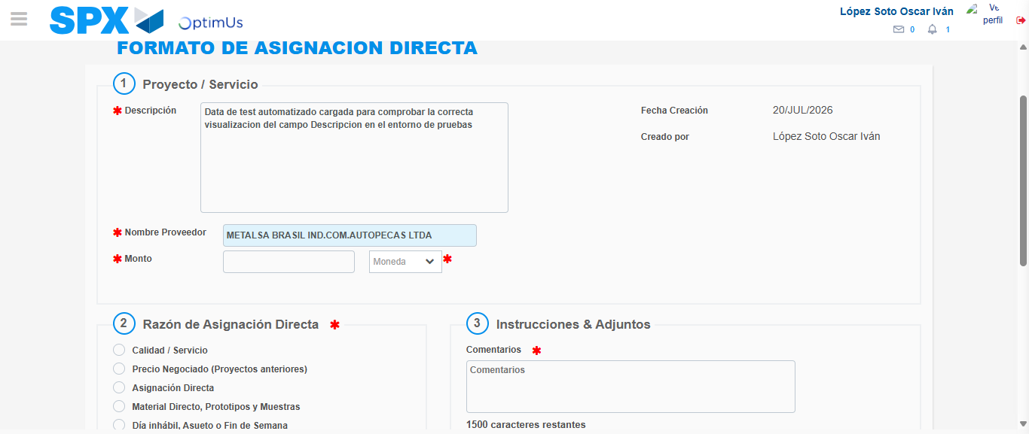Image file-name: QC_Testing-tc005_SPX_Dev5_Crear_Requisicion_Spot_Con_FAD_Tipo_Cobro_Project-1784571500945

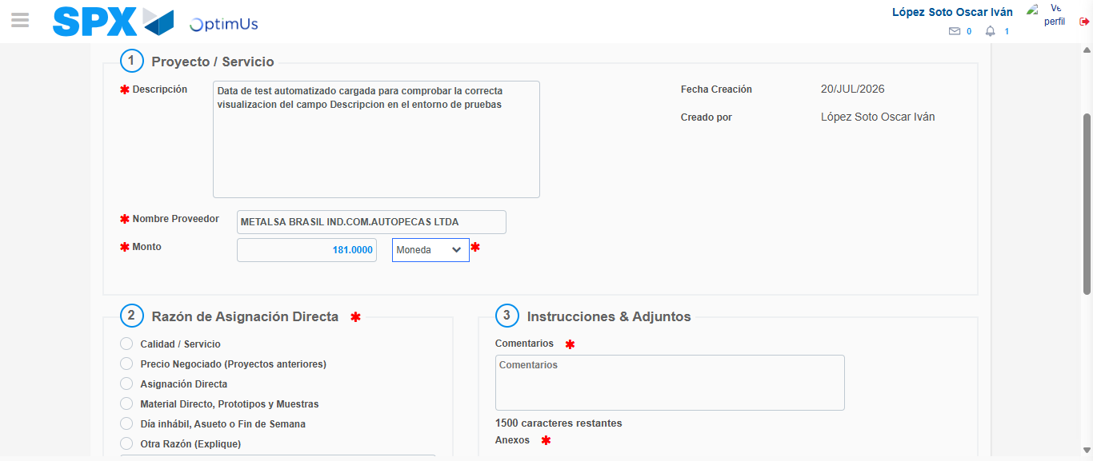Image file-name: QC_Testing-tc005_SPX_Dev5_Crear_Requisicion_Spot_Con_FAD_Tipo_Cobro_Project-1784571501336

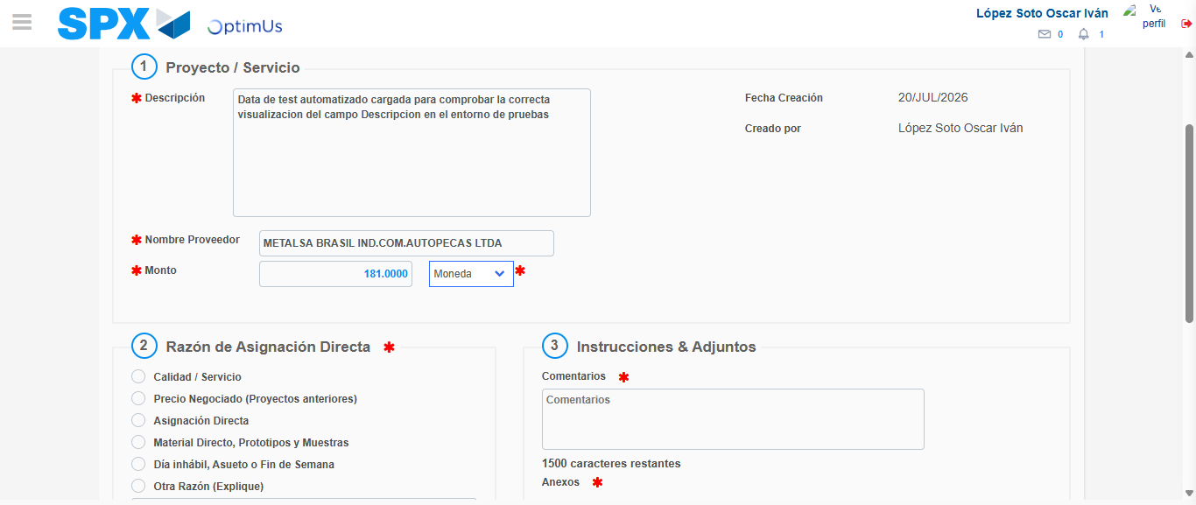Image file-name: QC_Testing-tc005_SPX_Dev5_Crear_Requisicion_Spot_Con_FAD_Tipo_Cobro_Project-1784571501542

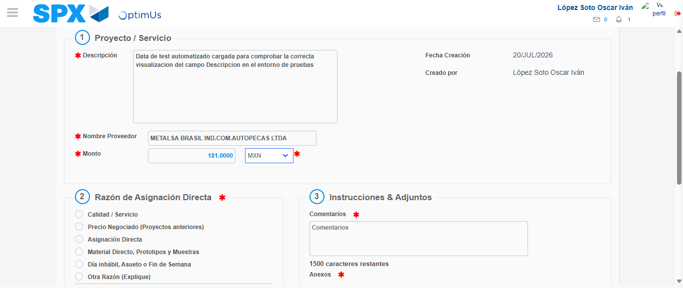Image file-name: QC_Testing-tc005_SPX_Dev5_Crear_Requisicion_Spot_Con_FAD_Tipo_Cobro_Project-1784571501864

Image file-name: QC_Testing-tc005_SPX_Dev5_Crear_Requisicion_Spot_Con_FAD_Tipo_Cobro_Project-1784571502057

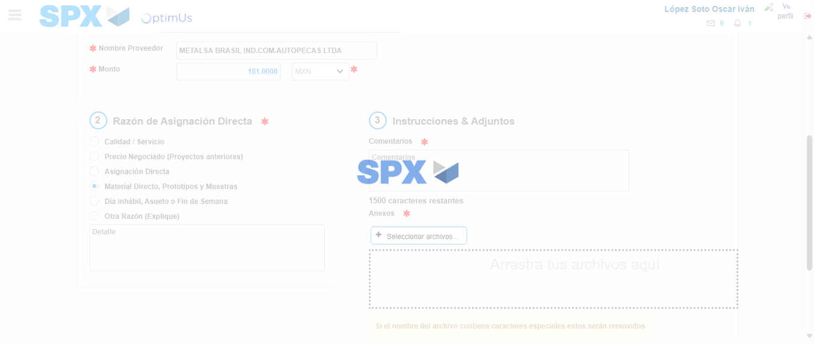Image file-name: QC_Testing-tc005_SPX_Dev5_Crear_Requisicion_Spot_Con_FAD_Tipo_Cobro_Project-1784571502896

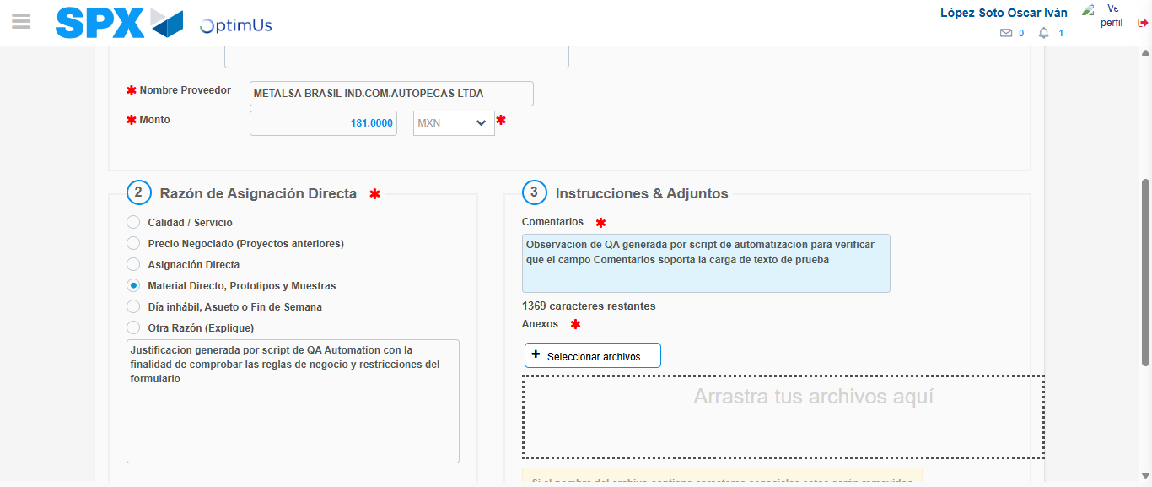Image file-name: QC_Testing-tc005_SPX_Dev5_Crear_Requisicion_Spot_Con_FAD_Tipo_Cobro_Project-1784571513930

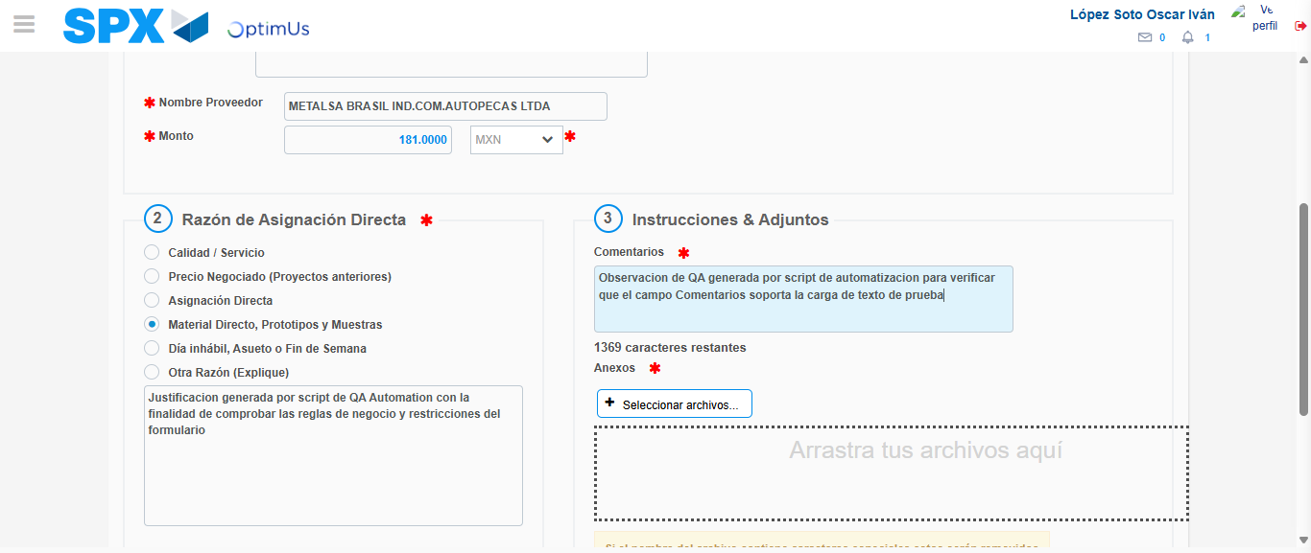Image file-name: QC_Testing-tc005_SPX_Dev5_Crear_Requisicion_Spot_Con_FAD_Tipo_Cobro_Project-1784571514492

Step 4 - Data Capture Spot Buy Requisition: Data captured correctly
Image file-name: QC_Testing-tc005_SPX_Dev5_Crear_Requisicion_Spot_Con_FAD_Tipo_Cobro_Project-1784571491998

Image file-name: QC_Testing-tc005_SPX_Dev5_Crear_Requisicion_Spot_Con_FAD_Tipo_Cobro_Project-1784571492177

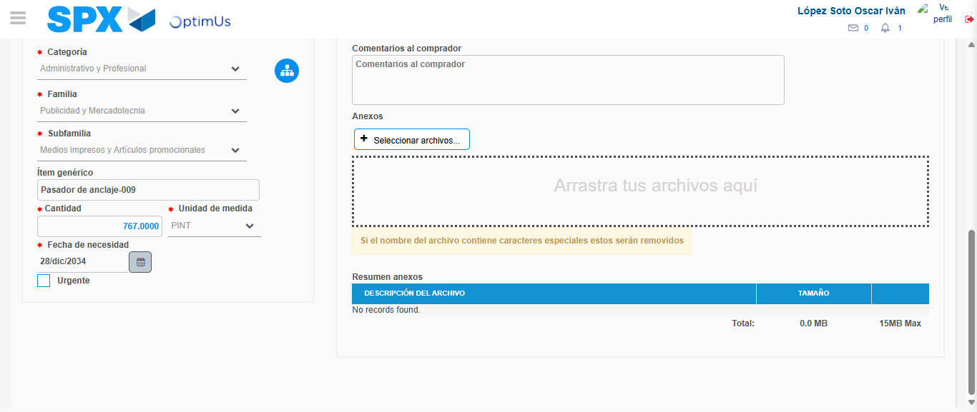Image file-name: QC_Testing-tc005_SPX_Dev5_Crear_Requisicion_Spot_Con_FAD_Tipo_Cobro_Project-1784571528104

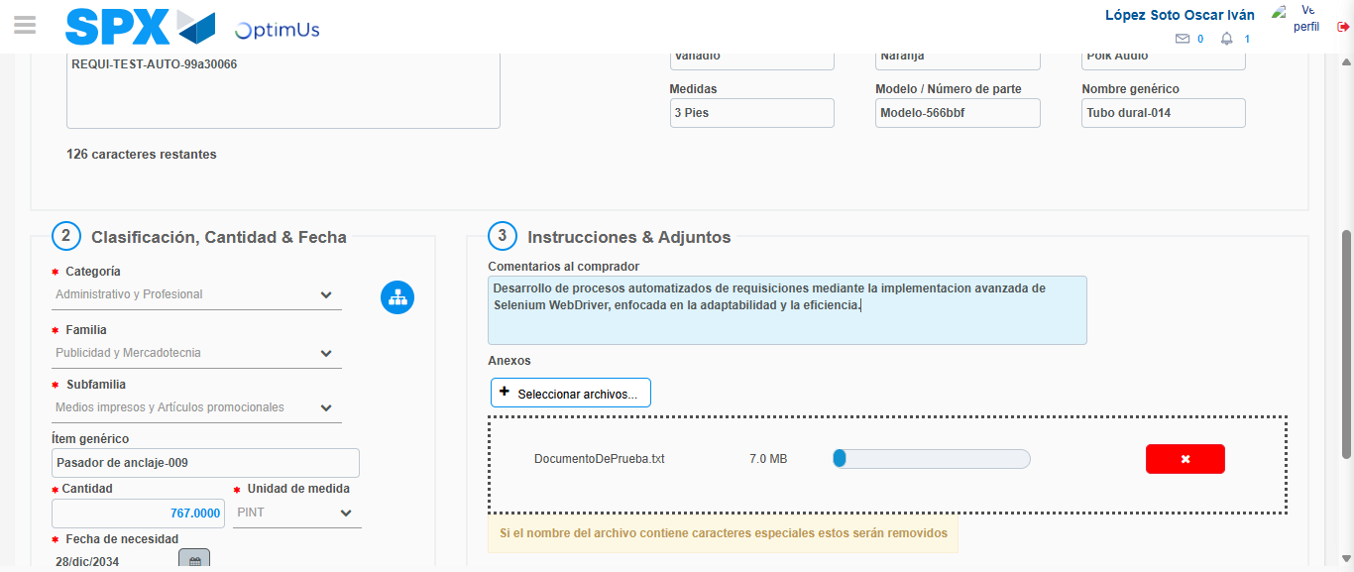Image file-name: QC_Testing-tc005_SPX_Dev5_Crear_Requisicion_Spot_Con_FAD_Tipo_Cobro_Project-1784571528861

Step 8 - Return to Main Page SPX : Return to Main Page SPX
Image file-name: QC_Testing-tc005_SPX_Dev5_Crear_Requisicion_Spot_Con_FAD_Tipo_Cobro_Project-1784571471045

Image file-name: QC_Testing-tc005_SPX_Dev5_Crear_Requisicion_Spot_Con_FAD_Tipo_Cobro_Project-1784571473558

Image file-name: QC_Testing-tc005_SPX_Dev5_Crear_Requisicion_Spot_Con_FAD_Tipo_Cobro_Project-1784571491773

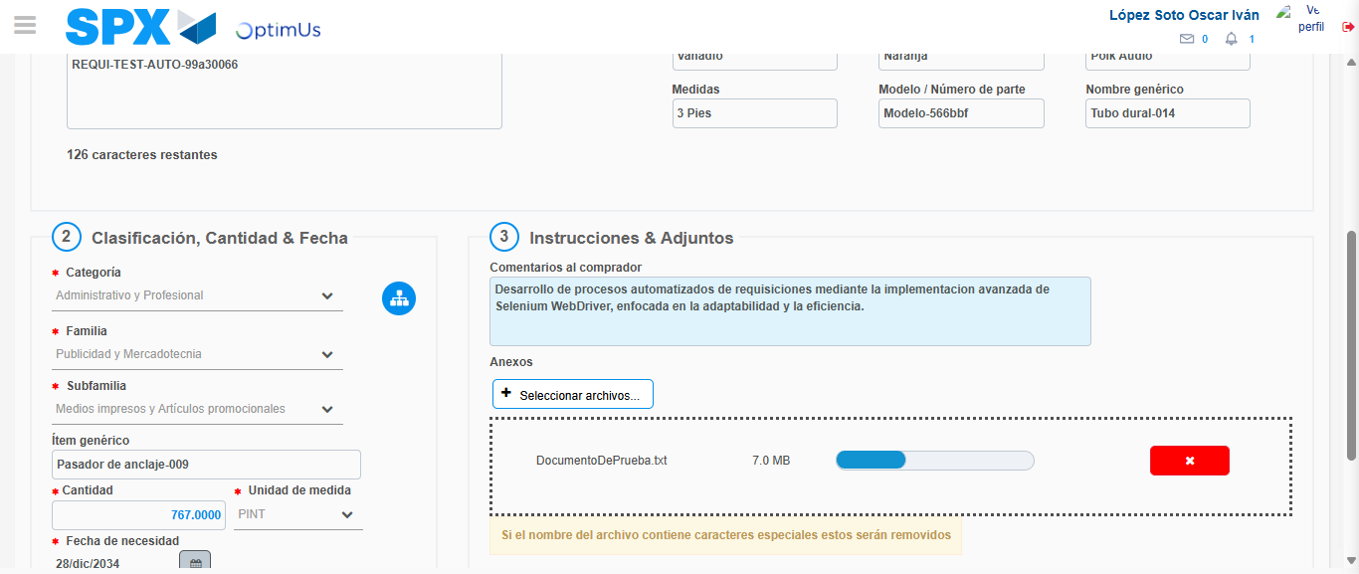Image file-name: QC_Testing-tc005_SPX_Dev5_Crear_Requisicion_Spot_Con_FAD_Tipo_Cobro_Project-1784571531128

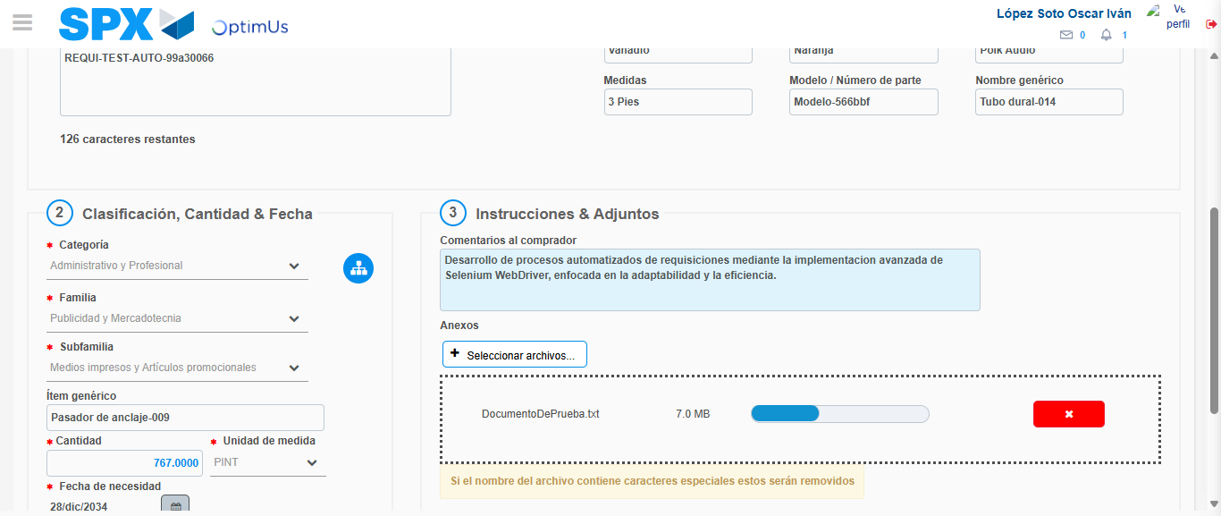Image file-name: QC_Testing-tc005_SPX_Dev5_Crear_Requisicion_Spot_Con_FAD_Tipo_Cobro_Project-1784571531333

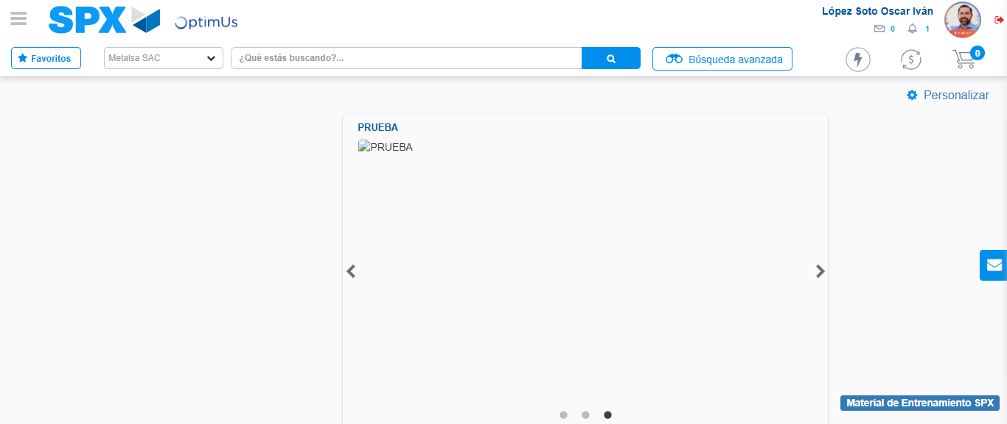Image file-name: QC_Testing-tc005_SPX_Dev5_Crear_Requisicion_Spot_Con_FAD_Tipo_Cobro_Project-1784571552343

Step 9 - Log Out : Log Out SPX
Image file-name: QC_Testing-tc005_SPX_Dev5_Crear_Requisicion_Spot_Con_FAD_Tipo_Cobro_Project-1784571552534

